A Project Report On

Hospital Management System

Submitted in partial fulfillment of the requirement for the award of the degree

Bachelor of Computer Application
BCA

Academic Year 2025 – 26

Prince Jakhotra Het Padariya Dharmik Jiyani
92300527149 92300527254 92300527173

Internal Guide
Dipak Thanki



Rajkot-Morbi Road, At & PO : Gauridad, Rajkot 360 003. Gujarat. India.

Faculty of Computer Applications (FCA)



This is to certify that the project work entitled

Hospital Management System

submitted in partial fulfillment of the requirement for

the award of the degree of

Bachelor of Computer Application
BCA

of the

Marwadi University

is a result of the bonafide work carried out by

Prince Jakhotra (92300527149)

Het padariya (92300527254)

Dharmik jiyani (92300527173)

during the academic year 2025-26

Dipak Thanki Dr.sunil Bajeja Dr . R.Shridaran
Faculty Guide |  | HOD |  | Dean

DECLARATION

We hereby declare that this project work entitled Hospital Management System is a record done by me.

I also declare that the matter embodied in this project is genuine work done by me and has not been submitted whether to this University or to any other University / Institute for the fulfillment of the requirement of any course of study.

Place : Marwadi University
Date : 06/06/2025

Prince Jakhotra (92300527149) Signature : prince
Het Padariya (92300527254) Signature : het
Dharmik Jiyani (92300527173) Signature : dharmik

CONTENTS

Chapters | Particulars | Page No.
1 | SYNOPSIS | 7
2 | PREAMBLE  General Introduction  Module description | 8
3 | TECHNICAL DESCRIPTION  Hardware Requirement  Software Requirement | 9
4 | SYSTEM DESIGN AND DEVELOPMENT  (Only applicable diagrams)  - Flowchart  - Data Flow Diagram, Use Case Diagram,  - Sequential Diagram, Class Diagram,  - Activity Diagram  Database Design (If applicable)  Screen Design & Coding | 11
5 | CONCLUSION | 16
6 | LEARNING DURING SIP | 17
7 | BIBLIOGRAPHY  Online References  Offline References | 18

1.Table Index

Table no. | Title | Page no.
Table no. 3.1 | Hardware requirement | 10
Table no 3.2 | Software Requirement | 10

2.figure index

Table no. | Title | Page no.
Figure no 4.1 | Flow Chart | 13
Figure no 4.2 | DataFlowDiagram,UseCaseDiagram | 14
Figure no 4.3 | Sequential Diagram, Class Diagram | 15
Figure no 4.4 | Login Screen | 16
Figure no 4.5 | Home Screen | 16

1.SYNOPSIS:

1. Introduction:
In the modern age of digital transformation, hospitals require a robust and efficient management system to handle complex operations. The Hospital Management System (HMS) is a comprehensive solution that facilitates seamless coordination of healthcare services, improves patient care, and automates administrative processes.

2. Objectives of the Project:
- To develop an efficient, scalable, and secure web-based hospital management system.
- To manage patient records digitally and reduce paperwork.
- To simplify appointment scheduling, billing, and report generation.
- To improve data accessibility and decision-making in healthcare.

3. Methodology / Development Approach:
- Backend Language: Python
- Framework Used: Tkinter

2.PREAMBLE

2.1 General Introduction:

➤ The Hospital Management System (HMS) is a software application designed to streamline and manage the day-to-day operations of a hospital or healthcare institution. This system enables the efficient handling of activities such as patient registration, appointment scheduling, doctor management, medical records, billing, and reporting.
➤ The primary goal of an HMS is to ensure smooth administrative processes, minimize human errors, and improve patient care quality by automating repetitive and complex tasks. By digitizing records and providing real-time access to critical data, the HMS enhances operational efficiency and ensures a better healthcare experience.

2.2 Module Description:

1. Admin Module
Description:
This module provides the administrator with full control over the system. The admin can manage all users (doctors, staff, patients), view reports, assign roles, and maintain data integrity.

2. Doctor Module
Description:
The doctor module is designed for medical professionals to manage their patient interactions, schedules, and prescriptions.

3. Patient Module
Description:
This module allows patients to interact with the hospital system, view their details, and manage appointments.

4. Staff/Receptionist Module

Description:
The staff or receptionist module handles front desk tasks like new patient registration, appointment management, and billing.

5. Appointment Scheduling Module
Description:
This module manages all appointments between patients and doctors. It ensures no conflicts occur and slots are managed efficiently.

6. Medical Records Module
Description:
Maintains a digital database of all patient records, including visit history, diagnosis, treatments, and prescriptions.

7. Billing and Payment Module
Description:
This module handles financial transactions, billing generation, and payment tracking.

8. Reports Module
Description:
Generates system reports for admin and doctors for analysis and recordkeeping.

3. Technical Description:
Hardware Requirement

Minimum Hardware Requirements :
Component | Specification
processor | Intel Core i3 or equivalent
RAM | 4 GB riquriment
Hard Disk | 100 GB (minimum 500 MB for project)
monitor | 14” or higher, with 1024x768 resolution
Keyboard & mouse | Standard input devices
Network | LAN/Wi-Fi adapter for local hosting
Table no. 3.1 Hardware Requirement

Software Requirement:

Operating system | Windows 8/10/11 or Linux/window
Programming Language | Python 3.x
Libraries used | Or GUI design  Csv –for handling file storage
Datetime | for add functionalities and view
os | For file path handling
Table no. 3.2 Software requirement

Operating System:
- Windows 10 or higher

Backend Technologies:
- Python 3.8 or higher
- tkinter

Development Tools:
- IDE/Editor: Visual Studio Code
- Browser: Google Chrome, Mozilla Firefox, Microsoft Edge
- Package Manager: pip (Python Package Installer)

4. SYSTEM DESIGN AND DEVELOPMENT :
Flowchart: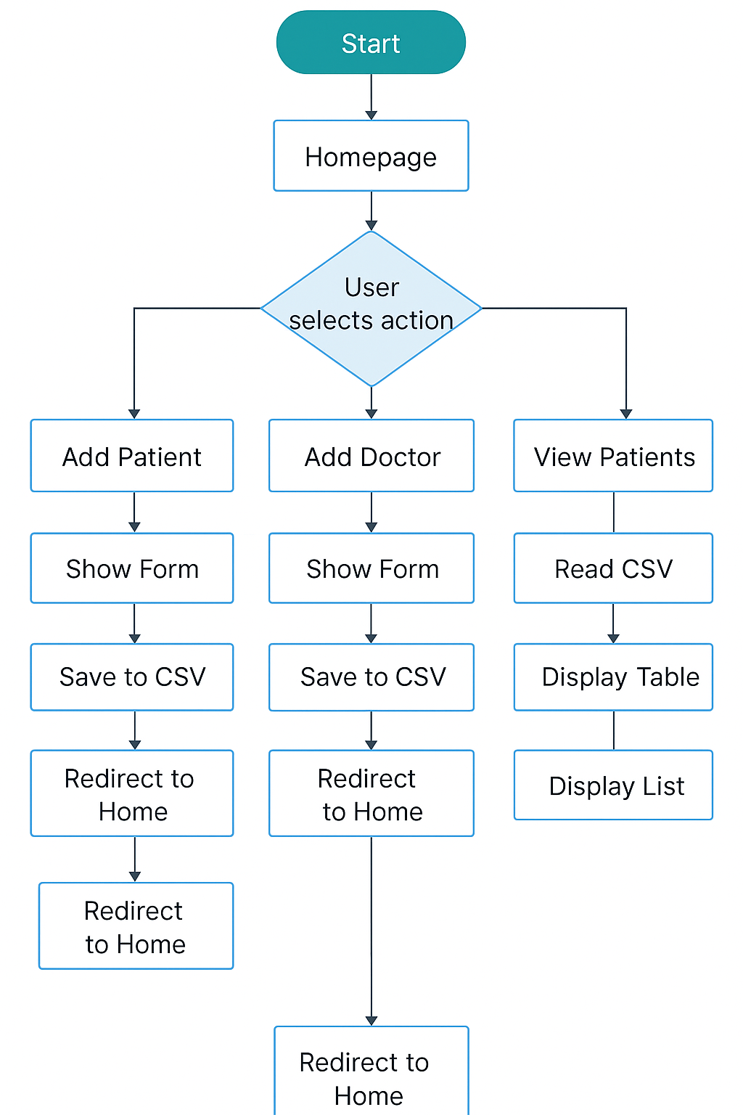

Figure no.4.1 Flow-chart
DataFlowDiagram,UseCaseDiagram :

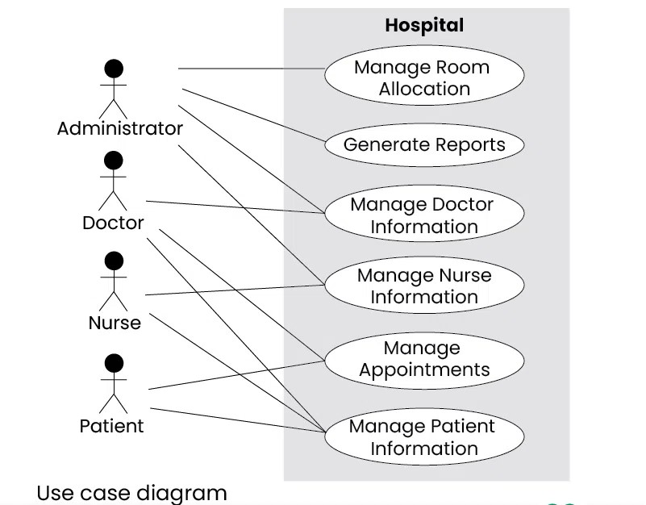

Figure no.4.2 DataFlowDiagram,UseCaseDiagram :

Sequential Diagram, Class Diagram:

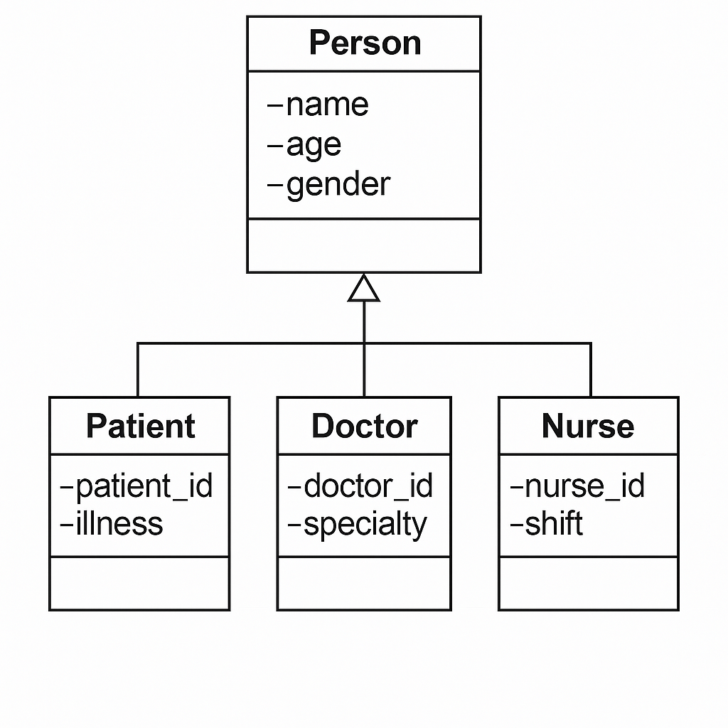
Figure no.4.3 Sequential Diagram, Class Diagram

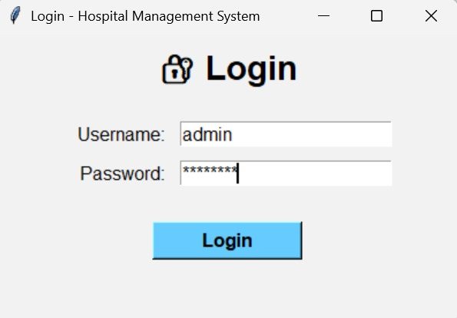
4.4 Login screen

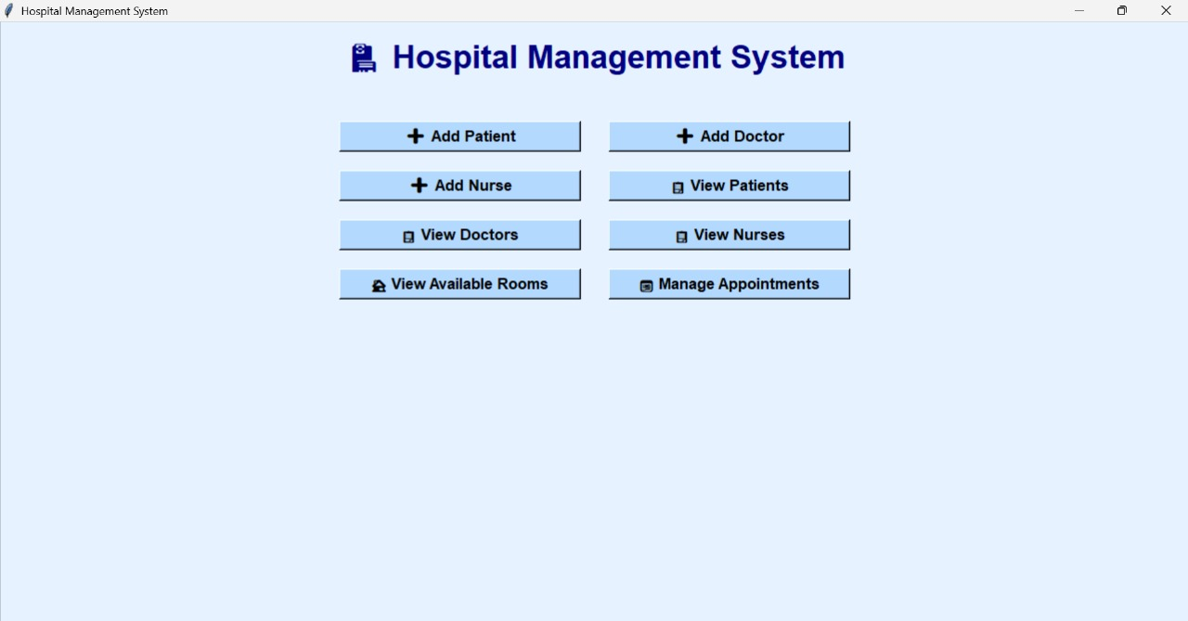

4.5 Home screen

Screen Design & Coding :

What platform are you targeting?
- Web (PYTHON)
- Desktop (Python with Tkinter etc.)

Which screens do you need designed and coded?
For example:
- Add patient
- Add doctor
- Add nurse
- View patient
- View room

5.CONCLUSION:

➤ The development of the Hospital Management System (HMS) project has provided valuable insights into healthcare data handling and system design. Through the creation of flowcharts, UML diagrams (class, use case, sequence), data flow diagrams, and activity diagrams, the system was effectively modeled to streamline operations such as patient registration, staff management, and doctor-patient interaction.

6.LEARNING DURING SIP :

During the Summer Internship Project (SIP), several key technical and professional skills were developed, particularly through the design and modeling of a Hospital Management System. The learning can be categorized as follows:

1. Technical Skills:
- System Analysis & Design:
Gained a deep understanding of how to analyze system requirements and represent them using diagrams such as:
  - Use Case Diagram
  - Class Diagram
  - Activity Diagram
  - Data Flow Diagram
  - Sequence Diagram
Object-Oriented Concepts:
Understood inheritance, encapsulation, and modular design while modeling entities like Person, Doctor, Nurse, and Patient.

2. Analytical & Problem-Solving Skills:
- Identified functional and non-functional requirements of a hospital system.
- Solved design problems through abstraction and proper class structuring.
- Improved debugging and error handling strategies in design-level logic.

3. Documentation & Reporting:
- Practiced documenting technical systems clearly and concisely.
- Gained experience in creating professional project reports for academic and practical presentation.

7.BIBLIOGRAPHY:

7.1 Online References :

• Hospital Management System – GeeksforGeeks
https://www.geeksforgeeks.org/hospital-management-system/
• Hospital Management System – ResearchGate (Papers & Case Studies)
https://www.researchgate.net/publication/350481027_Hospital_Management_System
• TutorialsPoint – Hospital Management System Software Design
https://www.tutorialspoint.com/software_engineering/software_design_hospital_management.htm
• GitHub – Open Source Hospital Management Projects
https://github.com/search?q=hospital+management+system
• W3Schools – Backend Development (for tech like PHP, MySQL)
https://www.w3schools.com/
• Oracle Blog – Healthcare IT Systems
https://blogs.oracle.com/healthcare/

7.2 Offline References :

Here are the offline references (books, notes, and academic materials) used during the Hospital Management System (HMS) project:

1. Textbooks
- “Object Oriented Programming with C++” by E. Balagurusamy
Helped understand class structures, inheritance, and object-oriented principles relevant to modeling the system.
- “Software Engineering” by Ian Sommerville
Provided theoretical understanding of system development life cycle (SDLC), UML diagrams, requirement analysis, and design methodologies.
- “Database System Concepts” by Abraham Silberschatz, Henry F. Korth, and S. Sudarshan
Referenced for structured data storage and file handling basics, adapted for CSV-based storage.

2. Lecture Notes and Class Materials
- Notes from System Analysis and Design (SAD) course
Used for preparing Data Flow Diagrams (DFD), Use Case Diagrams, and Activity Diagrams.
- Notes from Web Technology and Python Programming lab sessions
Assisted in developing the Flask-based backend and managing CSV files for data.

3. Institutional Resources
- Lab Manuals & Project Guidelines provided by the college/university
Used to format the SIP report structure, ensure diagram standards, and maintain documentation guidelines.

